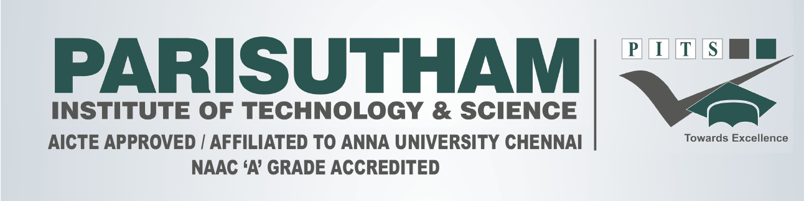

**AY 2022 – 23 I YEAR (Common to ALL Branches)I Sem. DAT-I**

**CY3151 – ENGINEERING CHEMISTRY**

**Duration: 50 Min Max. Marks: 25**

|  |  |  |  |
| --- | --- | --- | --- |
| **PART - A (6 x 2 = 12 MARKS)** | | | |
| **1.** | Define BOD. | | |
| **2.** | What is Brackish water? | | |
| **3.** | What are the difference between Zeolite process and ion-exchange process? | | |
| **4.** | What are boiler troubles? | | |
| **5.** | How is removed colour from water? | | |
| **6.** | What is Caustic embrittlement? | | |
| **PART - B (1 x 13 = 13 MARKS)** | | | |
| **7.** | **i)** | Describe the Reverse osmosis method for desalination of water. | **(6)** |
|  | **ii)** | Describe Demineralisation of water softening. Explain the reactions involved. | **(7)** |

**ACADEMIC COUNSELOR HOD**



**AY 2022 – 23 I YEAR (Common to ALL Branches)I Sem. DAT-I**

**CY3151 – ENGINEERING CHEMISTRY**

**Duration: 50 Min Max. Marks: 25**

|  |  |  |  |
| --- | --- | --- | --- |
| **PART - A (6 x 2 = 12 MARKS)** | | | |
| **1.** | Define BOD. | | |
| **2.** | What is Brackish water? | | |
| **3.** | What are the difference between Zeolite process and ion-exchange process? | | |
| **4.** | What are boiler troubles? | | |
| **5.** | How is removed colour from water? | | |
| **6.** | What is Caustic embrittlement? | | |
| **PART - B (1 x 13 = 13 MARKS)** | | | |
| **7.** | **i)** | Describe the Reverse osmosis method for desalination of water. | **(6)** |
|  | **ii)** | Describe Demineralisation of water softening. Explain the reactions involved. | **(7)** |

**ACADEMIC COUNSELOR HOD**